SMALL STEPS. BIG WINS.
Category: Multi Touch Campaign

Content Story:
The SAP Concur Enterprise Field Marketing Team, Content Strategy Team, Demand Generation Team, and Program Management came together in 2022 to develop a campaign around AP automation that would help solve a simple challenge for our prospective customers and cross-sell customers. Amongst business processes, AP and invoicing is still to this day, heavily paper-based which, during the pandemic, became painfully clear. Invoices sat on employee’s abandoned desks and remained unpaid with no employees in office to pay them, or redirect them -- causing vendor relationship issues, cash flow issues, and employee frustration. Still, after things eased up a bit, customers and prospects where still oftentimes intimidated to get an AP automation project going – the change management and digital transformation seemed overwhelming and daunting to our key targets. Enter the “Small Steps. Big Wins.” Campaign! This campaign set out to make the process of shifting AP from transactional to strategic by breaking down the steps and showing customers that SAP Concur solutions could help them make the transformation from paper-based to a fully automated, connected AP/P2P process something that they could transition to at their own pace based on where their biggest pain point was felt.

The team worked with their internal content strategy team, program management, and demand gen team, along with some valuable vendor partners, to develop a campaign that went from TOFU to BOFU. Using existing content and rebranding it with a campaign theme, as well as creating some net-new content -- through multi-touch funnel, acceleration, account based marketing, and cluster efforts, the team built awareness, accelerated interest, and eventually turned pipeline into closed-won deals while highlighting the value that small changes can make to our customer’s business.

Here are some examples of the content included in the campaign:

Core Messaging Content:

One Pager - The amount of manual effort involved in processing approvals, issuing payments, and paying vendors on time is painful. And while most organizations know they need to automate their AP processes to reduce complexity — they often don’t know where to start. Here is a framework to help. Blog post.

Infographic: Visual representation of the content contained in the one-pager. Leads to AP Risk Assessment interactive tool.

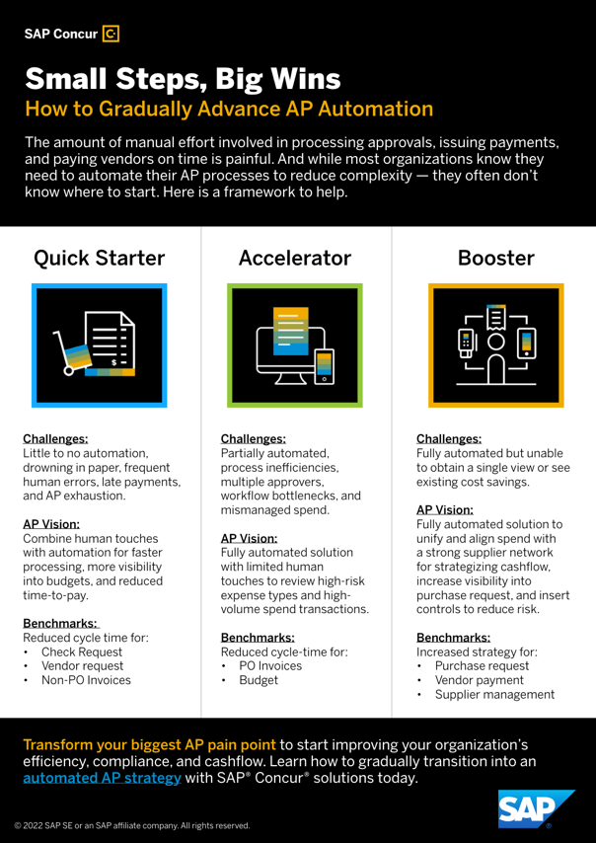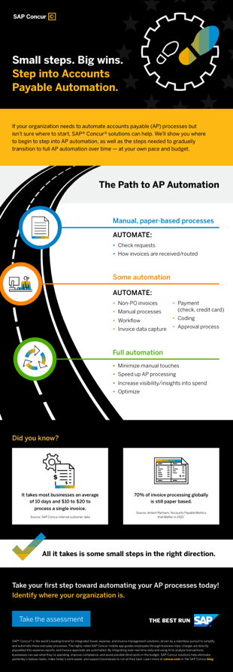

TOFU content to set up the business challenge:

(Quick Starter)
Tip Sheet: The Top 5 AP Pitfalls and How to Avoid Them – Imagine an accounts payable (AP) department with clean desks, no paper invoices or checks to cut, and regular eight-hour workdays – even during close. We live in a world where nearly everything is digital, yet AP still hasn’t caught up. Read on to learn the top five AP pitfalls holding you back from maximizing your savings and optimizing your organization’s cash flow.

Tip Sheet: The Four Costs Hiding in Accounts Payable - How much different can accounts payable (AP) really be? That’s up to you. Your accounts payable (AP) staff shouldn’t have to manually enter data, chase emails, and scan paper. Leverage these tips to see AP differently.

EBook: 8 Questions to Ask About Your AP System - Choosing the right AP system can feel overwhelming. There are a lot of cloud vendors out there, how do you figure out which to consider and how do you compare the differences? This eBook highlights eight questions that you should ask about your organization‘s AP system. Once you ask yourself the answers to these questions, it will be easier to decide which software vendors align with your organization‘s business outcomes.

(Accelerator/Booster)
Tip Sheet: 8 Tips to Boost Employee Purchasing Power - If your organization has employees who are new to making business purchases, they may not know how to maximize your supplier relationships or make the most cost-effective buying decisions. To help your organization succeed, here are eight tips for demystifying the purchasing process.
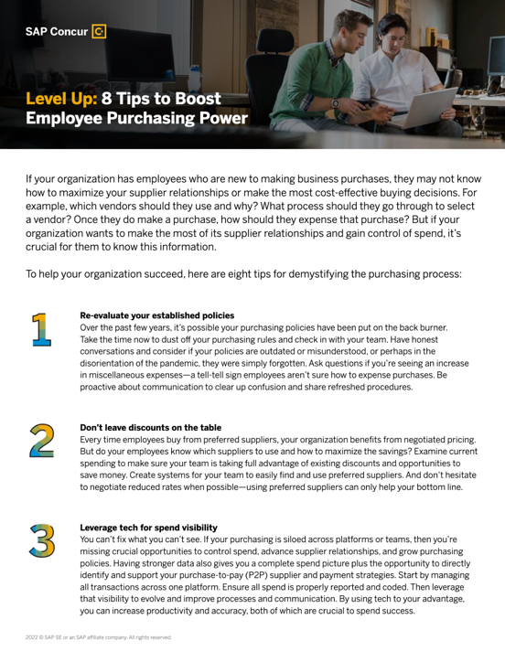
Blog Article: 5 Steps to Supercharge Your Organization’s Purchasing Power

Direct Mail Kit

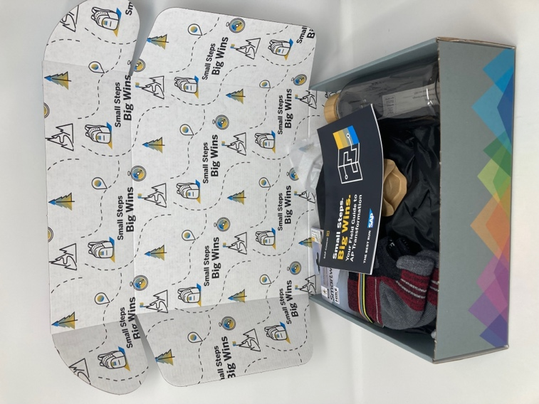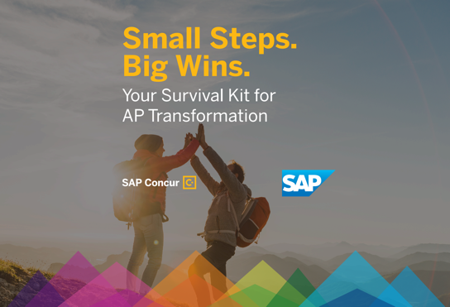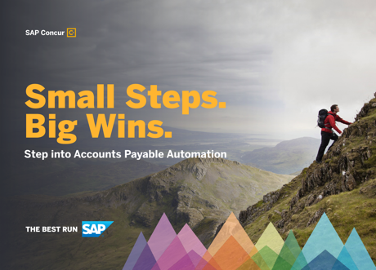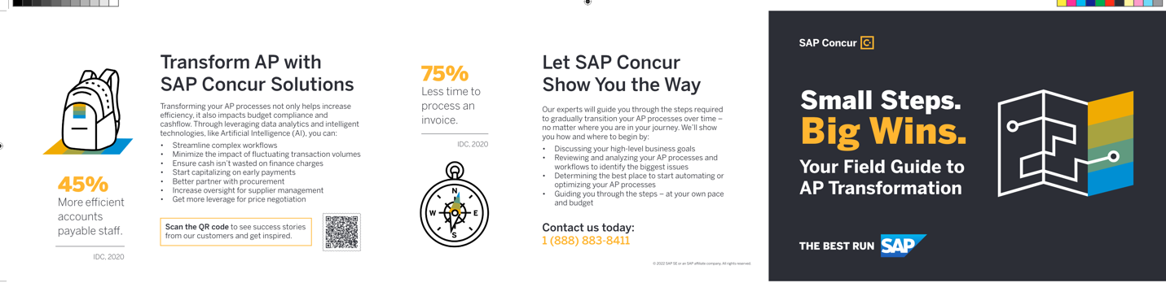
Email and Digital
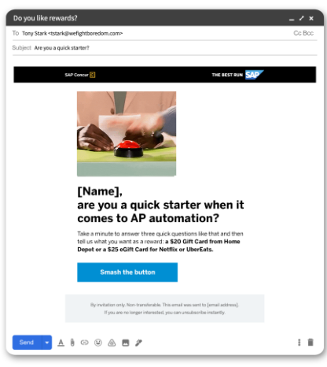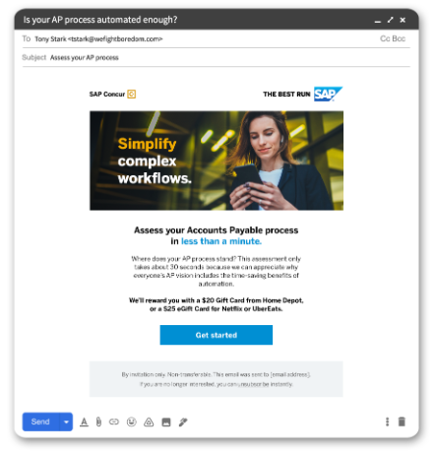

Key KPI:
Digital ads had an ROI of 9,470% and CTR improvement of 325%
Targeted Accounts with our digital strategy were 2.62x more likely to convert on our website
Collected over 1,300 new leads globally from our efforts
Over 4,700 campaign engagements
Over $3.3million in direct campaign pipeline
Created and executed over 43 campaign tactics in 2022 for this effort

Agency Partners:
Content 4 Demand – messaging pillars, badge branding, infographic, blog post
VLG: Interactive experience and personalized outreach
PFL: Direct mail gift procurement, printing, and fulfillment
DemandBase – Vendor selected for account digital targeting efforts

